

Topic test 2
Name: __________________________________

Chapter 3: Trigonometry

• Time allowed: 45 minutes
• CAS calculators may be used.
• Part A: 5 multiple-choice questions (5 marks)
• Part B: 10 short answer questions (46 marks)
• Part C: 2 analysis questions (20 marks)
Part A
5 multiple-choice questions
1 mark each: 5 marks
Circle the correct answer.
1 Which statement is true?
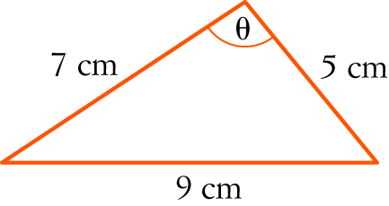
A cos (θ) = 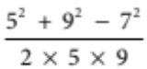
B cos (θ) = 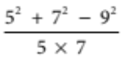
C cos (θ) = 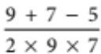
D cos (θ) = 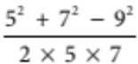
E cos (θ) = 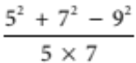

[1 mark]
2 tan 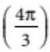 =
A 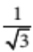
B 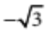
C 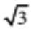
D 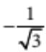
E 1

[1 mark]
3 What is the volume of the figure below?
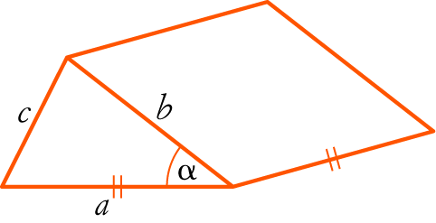
A V = a2b sin ()
B V = abc sin ()
C V = abc cos ()
D V = a2c sin ()
E V = a2b cos ()

[1 mark]
4 Which statement is NOT true?
A cos (360° − θ) = −cos (θ)
B sin (180° − θ) = sin (θ)
C tan (360° − θ) = −tan (θ)
D cos (−θ) = cos (θ)
E sin (180° + θ) = −sin (θ)

[1 mark]
5 What is the true bearing of B from A in the figure below?
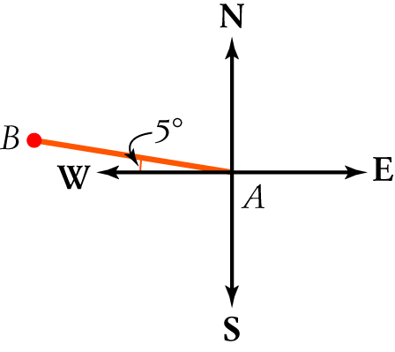
A 005°
B 085°
C 265°
D 185°
E 275°

[1 mark]
Part B
10 short answer questions
46 marks
Show your working where appropriate.
1 Convert the following to degrees.
a
b 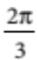
c 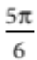
d 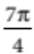
e 5π

[5 marks]
2 Convert the following to radians, correct to one decimal place.
a 74°

b 29°

c 108°

d 41.6°

e 84° 12′

[5 marks]

3 A road has an angle of inclination of 8° 52′. What is its gradient?

[1 mark]
4 Evaluate the following, correct to two decimal places.
a 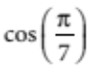 ____________________
b tan (0.9) ____________________ [2 marks]
5 A fountain is 21.5 m out from the base of a building. Amie is standing at a window in the building that is 7.3 m up from the ground. What is the angle of depression from Amie down to the fountain, correct to
one decimal place?

[3 marks]
6 Evaluate x correct to one decimal place.
a 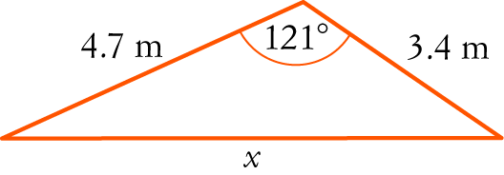
b 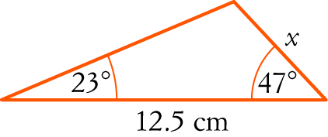

[7 marks]
7 A box with sides 8 cm, 7 cm and 5 cm has a piece of cardboard inserted inside it, as shown in the diagram below. Find the size of angle GAH, correct to the nearest degree.
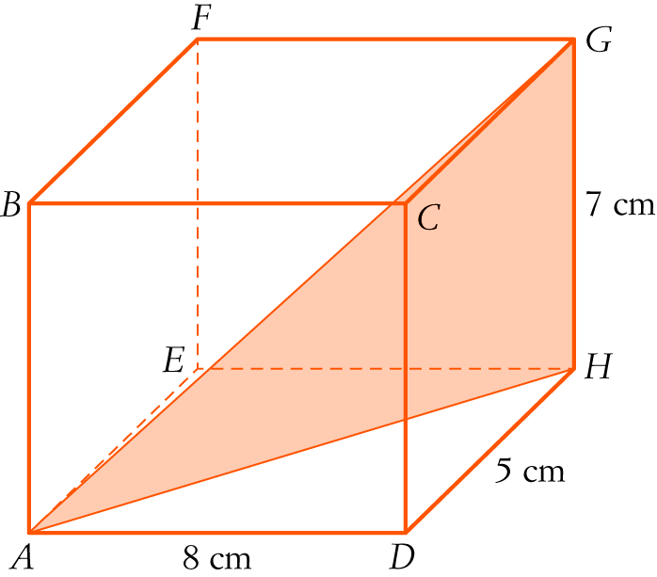

[4 marks]
8 A sector is cut off by an angle of 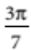 subtended at the centre of a circle with radius 8.6 cm.
a Find the length of the arc cut off by this angle.

[2 marks]

b Find the area of the sector.

[2 marks]
[4 marks]
9 State which quadrant each of the following angles are in.
a −50° ____________________
b 500° ____________________
c −285° ____________________
d 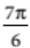 ____________________
e 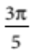 ____________________
f −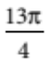 ____________________
[6 marks]
10 The circumference of a circle is 20 cm. Find the angle subtended at the centre if it cuts off a sector with an area of 15 cm2.

[5 marks]
Part C
2 analysis questions
20 marks
Show your working where appropriate.
1 A plane leaves Brisbane and flies for 113 km on a bearing of 058°. It then turns and flies on a second bearing for
154 km until it is 210 km due east of Brisbane. What is the second bearing, to the nearest degree?

[7 marks]
2 The diagram below shows a regular pentagon with sides of 10 m.
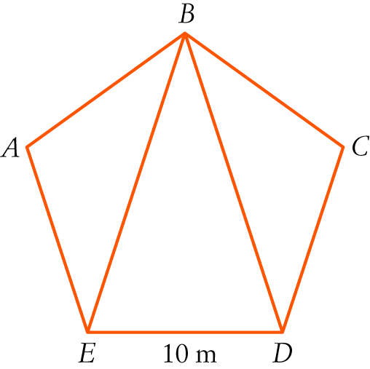
a Use the sum of angles in a triangle to find the angle sum of any pentagon.

b Find the size of each angle inside a regular pentagon.

c Find the length of BE in the pentagon above.

d Find the area of the pentagon.

[13 marks]
Total marks: 71
Answers
Part A [1 mark each]
1 Substituting into the cosine rule:
cos (C) = 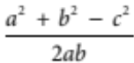
cos (θ) = 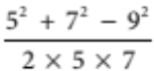
 D [1 mark]
2 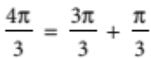
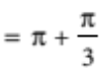
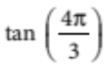 = 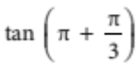
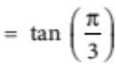 (3rd quadrant)
=
 C [1 mark]
3 V = Ah where h = a and
A 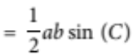
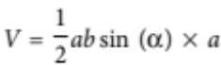
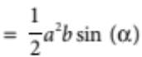
 A [1 mark]
4 A cos (360° − θ) = −cos (θ) is false (4th quadrant − cos is positive)
B sin (180° − θ) = sin (θ) is true (2nd quadrant − sin is positive)
C tan (360° − θ) = −tan (θ) is true (4th quadrant − tan is negative)
D cos (−θ) = cos (θ) is true (4th quadrant − cos is positive)
E sin (180° + θ) = −sin (θ) is true (3rd quadrant − sin is negative)
 A [1 mark]
5
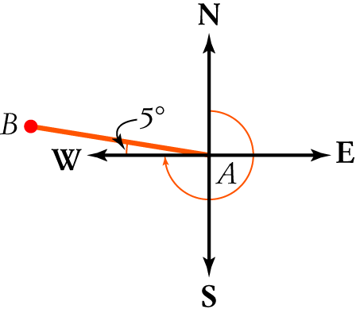
True bearings are measured clockwise from north.
The bearing is 270° − 5° or 265°.
 C [1 mark]
Part B
1 To convert to degrees, multiply by 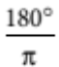 or simply replace π by 180°.
a 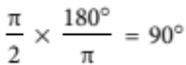or 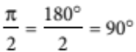 [1 mark]
b 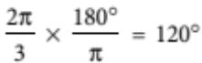 or 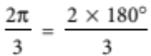 = 120° [1 mark]
c 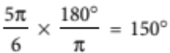 or 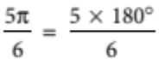 = 150° [1 mark]
d 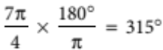 or 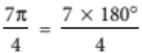 = 315° [1 mark]
e 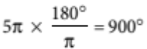 or 5  180° = 900° [1 mark]
2 To convert to radians, multiply by 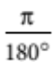.
a 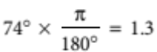 [1 mark]
b 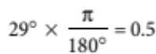 [1 mark]
c 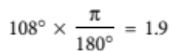 [1 mark]
d 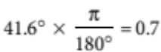 [1 mark]
e 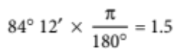 [1 mark]
3 Gradient = tan (8° 52′) = 0.16 [1 mark]
4 Set the calculator on radian mode.
a 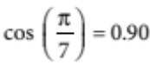 [1 mark]
b tan (0.9) = 1.26 [1 mark]
5 Draw a diagram showing the information.
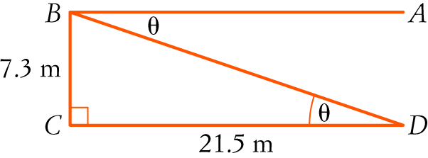 [1 mark]
The angle of depression is ∠ABD.
ABD = BDC since AB||DC
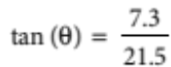 [1 mark]
θ = 18.8°
So the angle of depression is 18.8°. [1 mark]
6 a Substitute into the cosine rule:
c2 = a2 + b2 − 2ab cos (C)
x2 = 4.72 + 3.42 − 2 × 4.7 × 3.4 × cos (121°) [1 mark]
= 50.110 616 87… [1 mark]
x = 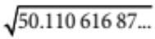
 7.1
So x = 7.1 m [1 mark]
b The 3rd angle in the triangle is 180° − (23° + 47°) or 110°. [1 mark]
Substitute into the sine rule:
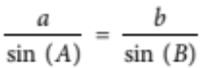
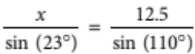 [1 mark]
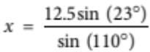 [1 mark]
 5.2
So x = 5.2 cm [1 mark]
7 Use Pythagoras’ theorem to find AH:
c2 = a2 + b2
AH2 = 82 + 52 [1 mark]
= 89
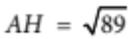 [1 mark]
Find angle GAH.
tan (GAH) = 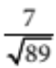 [1 mark]
       GAH = 37° [1 mark]
8 a Substitute into l = r θ:
l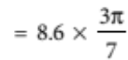 [1 mark]
= 11.6
So the arc length is 11.6 cm. [1 mark]
b Substitute into A = r 2θ:
A =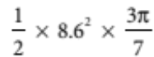 [1 mark]
= 49.8
So the area of the sector is 49.8 cm2. [1 mark]
9 a −50° is between 0° and −90° so it is in the 4th quadrant (turn anticlockwise 50°) [1 mark]
b 500° − 360° = 140° (turn around the circle more than once)
140° is between 90° and 180° so it is in the 2nd quadrant. [1 mark]
c −285° is between −270° and −360° so is in the 1st quadrant. [1 mark]
d 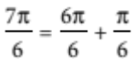 = 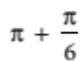 which is in the 3rd quadrant. [1 mark]
e 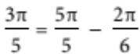 = 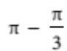 which is in the 2nd quadrant. [1 mark]
f 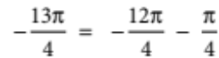 = 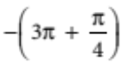= 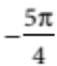 = 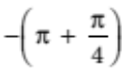 which is in the 2nd quadrant.
[1 mark]
10 Substitute in C = 2πr
20 = 2πr [1 mark]
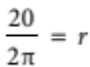
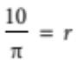 [1 mark]
Substitute into 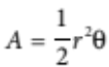
15 = 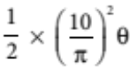 [1 mark]
= 5.066 θ
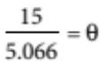 [1 mark]
2.96 = θ
So the angle is 2.96. [1 mark]
Part C
1 Draw a diagram to show the information.
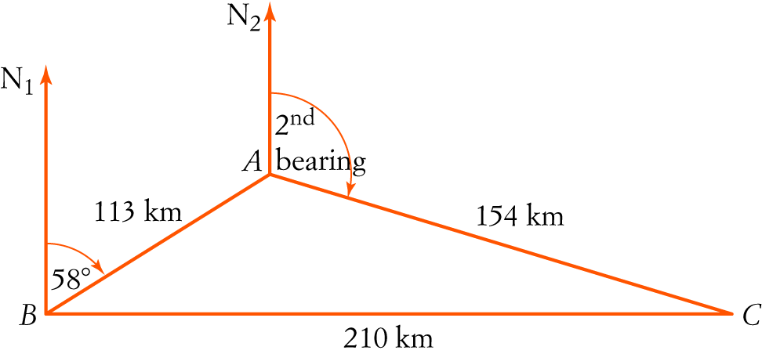 [1 mark]
Find BAC:
Substitute into the cosine rule:
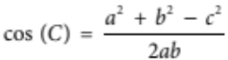
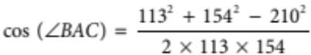 [1 mark]
= −0.21879669 [1 mark]
         BAC = 102.638…° [1 mark]
            BAN2 = 180° − 58°
= 122° [1 mark]
       CAN2 = 360° − (122° + 102.638…°) [1 mark]
= 135.361…°
So the second bearing is about 135°. [1 mark]
2 a A pentagon is made up of 3 triangles.
Angle sum = 3 × 180° = 540° [1 mark]
b There are 5 equal angles in a regular pentagon.
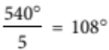
So each angle is 108°. [1 mark]
c Substitute into the cosine rule:
c2 = a2 + b2 − 2ab cos (C)
BE2 = 102 + 102 − 2 × 10 × 10 × cos (108°) [1 mark]
= 261.8033989 [1 mark]
BE = 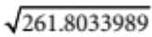
= 16.180…
So the length of BE is about 16.2 m. [1 mark]
d
Area of ΔABE:
Substitute into area formula 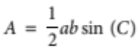:
A = 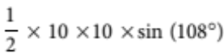 [1 mark]
= 47.552…
Area of ΔCBD is also 47.552… (both triangles are identical) [1 mark]
In ΔABE:
     ABE = 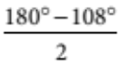 (base angles of an isosceles triangle)
= 36°
Similarly, ∠CBD = 36°
So EBD = 108° − 2 × 36°
= 36° [2 marks]
Area of ΔEBD:
A = 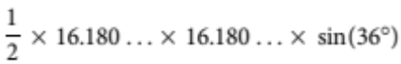 [1 mark]
= 76.942…
The area of ΔEBD is 76.942… m2. [1 mark]
Total area = 47.552… + 47.552… + 76.942… [1 mark]
= 172.047…
So the area of the pentagon is about 172.0 m2. [1 mark]

